## Forecasting *Doryteuthis Pealeii* Habitat Suitability in 2055 & 2075

By: Zane Chutkow

## Introduction

Shielded from the open ocean by the submerged islands of Georges Bank and Browns Bank, the Gulf of Maine fosters ecological conditions distinctly different from the surrounding waters. The Northeast Channel and the Labrador Current bring nutrient waters into the Gulf from the North. These cold inflows of the water have made the Gulf of Maine much colder than waters to the South, and as a result the Gulf fosters a number of species that could not survive south of Cape Cod.[1] In recent years, anthropogenic CO2 emissions have caused waters across the planet to warm, but temperatures have increased in the Gulf of Maine at a particularly high rate. Due to shifts in the Arctic currents to the North and the Gulf Stream to the South, the Gulf of Maine has warmed at seven times the global average.[2] This rapid change threatens the habitat of native species, and changing conditions have allowed southern species to migrate North where temperatures were previously too cold for them to live.

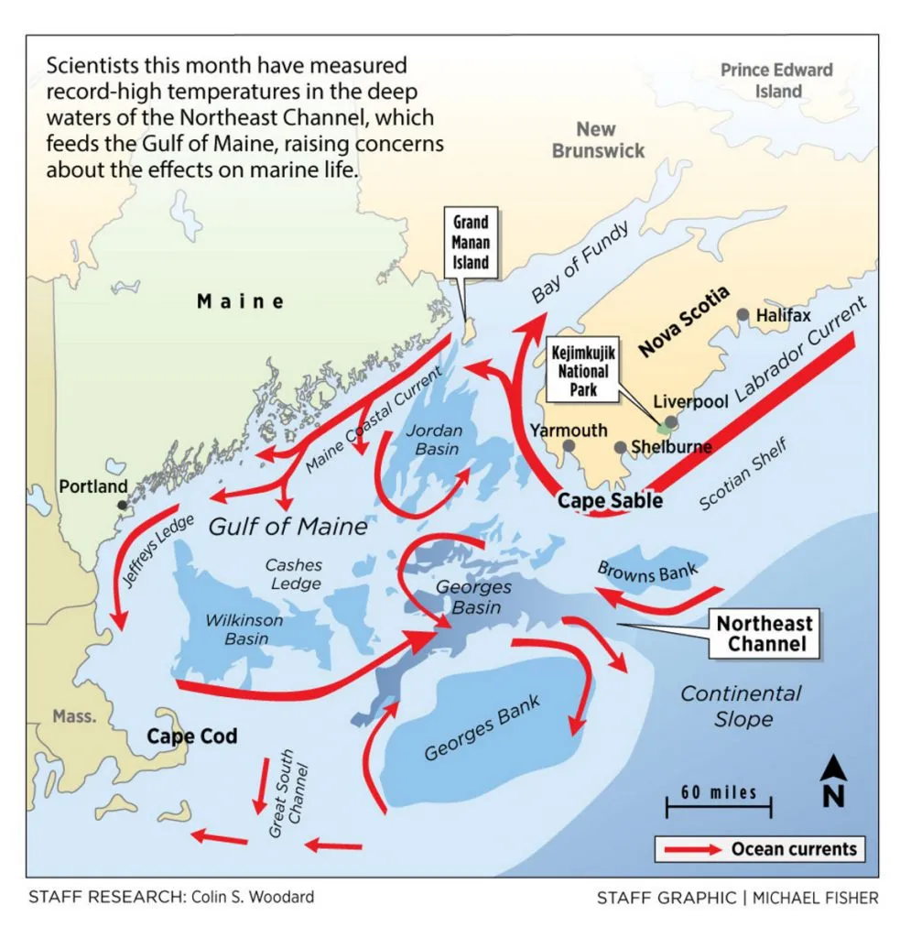

In 2012, the Gulf of Maine experienced a historic heatwave. During the first half of the year, temperatures throughout the Gulf were around 4 degrees fahrenheit higher than normal. The effects of this period of elevated temperature were felt throughout the ecosystem and the economy.

Prior to 2012, North Atlantic Shrimp was one of Maine’s most important fisheries, and catches were over ten million pounds annually.[3] However, in 2012, the stock of shrimp collapsed, and a moratorium was placed on shrimp landings. To this day, the shrimp population has never recovered. Due to several factors including increased temperatures, the crash in the shrimp population can largely be attributed to the arrival of a predator in the Gulf of Maine: the Longfin Squid.

The Longfin Squid (*Doryteuthis pealeii*) is a species of cephalopod commonly referred to as the “Winter” or “Boston Squid.” Longfins are prevalent along the Western coast of the Atlantic, all the way from Newfoundland down to the Gulf of Venezuela. However, Longfins are most abundant in the mid-Atlantic United States, from Cape Hatteras, North Carolina up to Georges Bank in the Gulf of Maine. Longfins live inshore during the spring and summer and migrate out to the continental slope before winter to find warmer waters.[4]

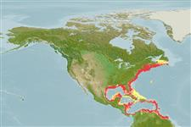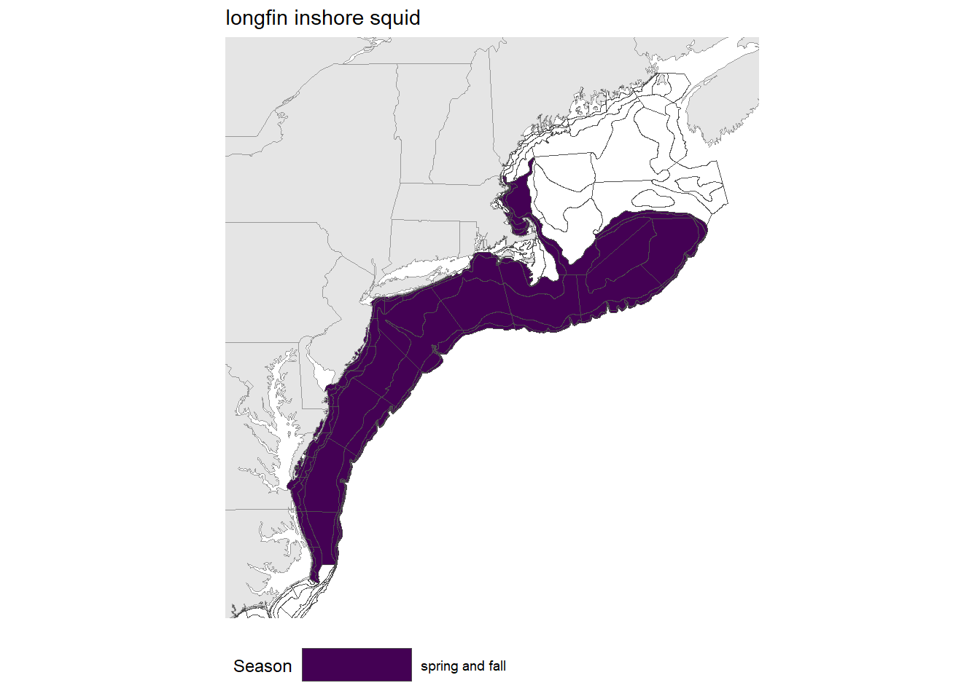

Longfins have short lifespans which are characterized by rapid growth. Longfins are alive for less than a year and grow to approximately a foot in length during this short time period. To sustain this development, juvenile Longfins consume a diet of planktonic organisms, while adults eat shrimp, fish, and small crustaceans. Longfins are a key source of food for large Atlantic fish like cod and haddock as well as marine mammals such as long-finned pilot whales and Atlantic dolphins. Longfin squid are crucial to the coastal food web of the western North Atlantic, acting as a connection between higher and lower trophic levels.[5]

This study focuses on forecasting potential Longfin habitats in the North-Atlantic region in an effort to predict how their populations will shift as a result of global warming. Habitat suitability maps for two climate change scenarios, RCP45 and RCP85, predict areas capable of fostering *Doryteuthis pealeii* in 2055 and 2075.

RCP45 predicts ecosystem measurement if humans manage to curb carbon emissions and RCP85 predicts what will happen with no change to human activity. This forecast could be used to help inform a number of decisions. By comparing forecasts for RCP45 and RCP85, policymakers can see how the distribution of D*oryteuthis pealeii* will vary based on decisions they make.Furthermore, by forecasting Longfin populations, scientists can gain a better understanding of how Longfin prey such as shrimp, crustaceans, and small fish will be affected by global warming.

## Data

The data used to create the forecasts was obtained from the Ocean Biodiversity Information System (OBIS) database. Each datapoint is a *Doryteuthis pealeii* observation in the Gulf of Maine region. Data was restricted to observations in the geographic area [70.875–65.375°W, 40.375–45.125°N].[6] Data was then narrowed down to only observations including the date of the observation. Finally, only observations listed as “HumanObservation” and “Occurrence” were included. The majority of these data points came from surveys beginning in 1974. There were several results from a survey done in 1903, which were filtered out because the survey was far outside of the temporal range of the rest of the data.

This filtering resulted in 16,290 observations to be used in the study. Of these, 8,518 had no individual count listed (the number of Longfin within each observation). Under typical circumstances, the data would be further narrowed down to exclude observations without individual counts. However, doing so would eliminate all observations after 2013. Thus, there would be no evidence Longfins shifted into the Gulf of Maine post 2012. This shift was a chief inspiration of this study and Longfin populations would not be accurately represented in forecasts if the data showed no shift. Under ideal conditions, all data points used in the model would have individual counts listed, but in order to include observations from 2013-2021, observations with no individual count were not filtered out.

The largest source of Longfin observations is from the NMFS NEFSC Bottom Trawl Survey. Trawlers surveyed fish from Cape Hatteras up to the Gulf of Maine. During this period, the survey area almost perfectly matched the common range of the Longfin, so there were quite a few observations. This survey is conducted during all four seasons, and still collects data at the time of this paper. However, survey data is only updated in OBIS through 2013. Post 2013, data comes from smaller trawl surveys such as Canadian Maritime Resources Trawl (1974-2021), and the Maritime Spring Research Survey (2000-2021).

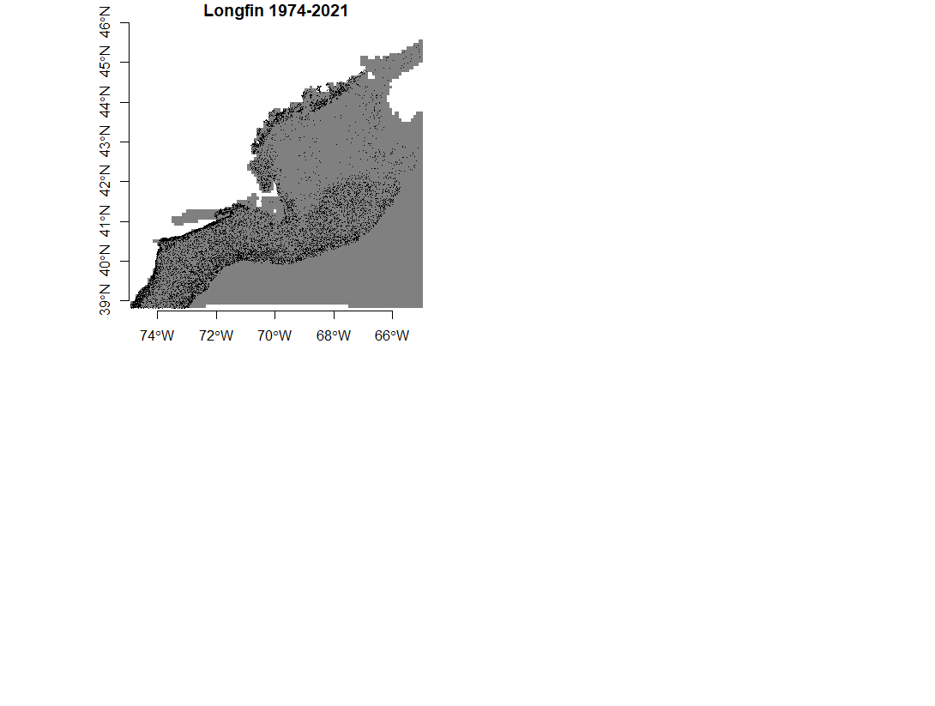

The plot above illustrates *Doryteuthis pealeii* observations from 1974 to 2021. Longfin observations are abundant along the coast of the US, from New Jersey up to Maine. Observations form a band further away from land from New Jersey up to Georges Bank. There is a distinct dropoff at the edge of the continental shelf.

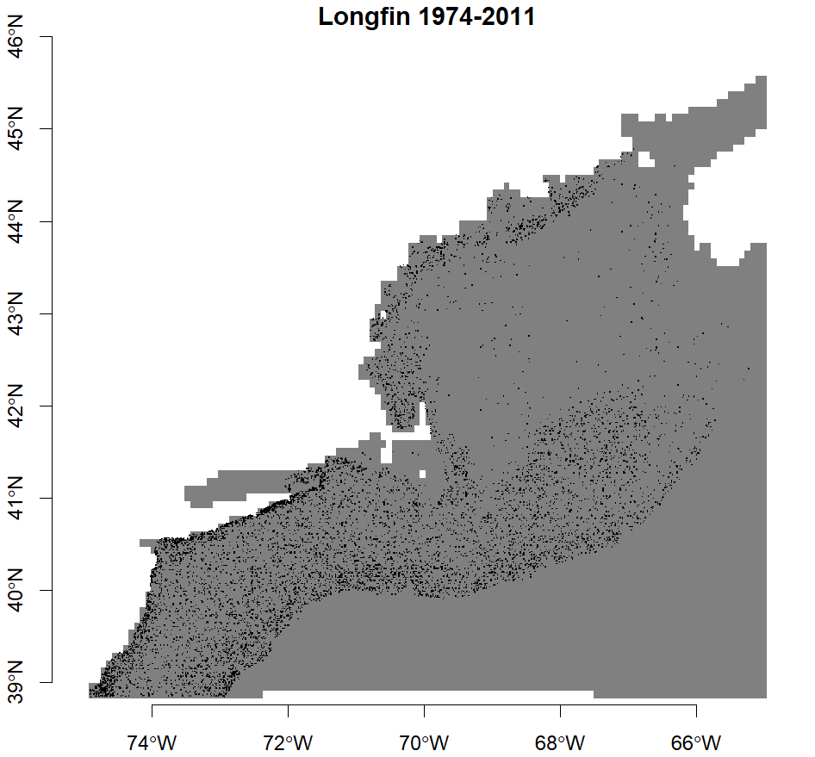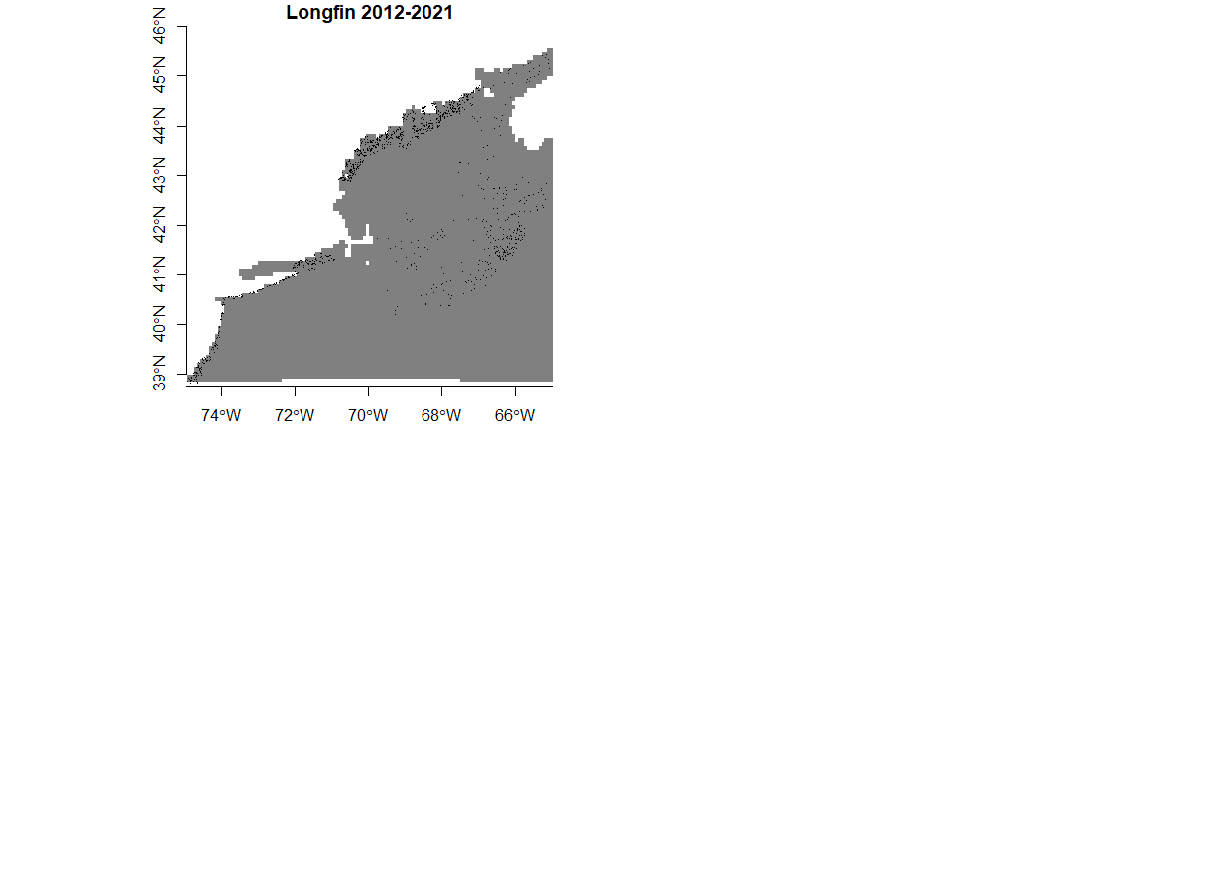

The above plots illustrate the observations of longfin squids from 1974 to 2011 and from 2012 to 2021. During this period, populations of Longfin have shifted northwards towards the coast of Maine and into the Bay of Fundy. One caveat is that the majority of data from before 2012 came from the NEFSC Bottom Trawl survey, and all of the data afterwards comes from other surveys. Longfin squids live in waters between 9 and 30 degrees Celsius and at longitudes all the way down to Venezuela. Although they did move into the Gulf of Maine, it is unlikely that the population declined so much south of Cape Cod. This decline could be due to the change in data sources.



1974-2011 2012-2021

The time series illustrate the monthly observations before and after the heat wave of 2012. In both plots, Longfin seasonal migration patterns can be seen. In the winter to early spring, Longfins live at the continental slope, where the water is warmer. In the summer, they move inwards towards the shore to reproduce. After 2012, there is a clear shift upwards towards the coast of Maine during the summer and early autumn. Additionally, Longfin are more abundant in the Bay of Fundy and off the coast of Cape Sable, Nova Scotia. It should be noted that there are much fewer data points after 2012 during the winter months, again likely due to the change in surveys.

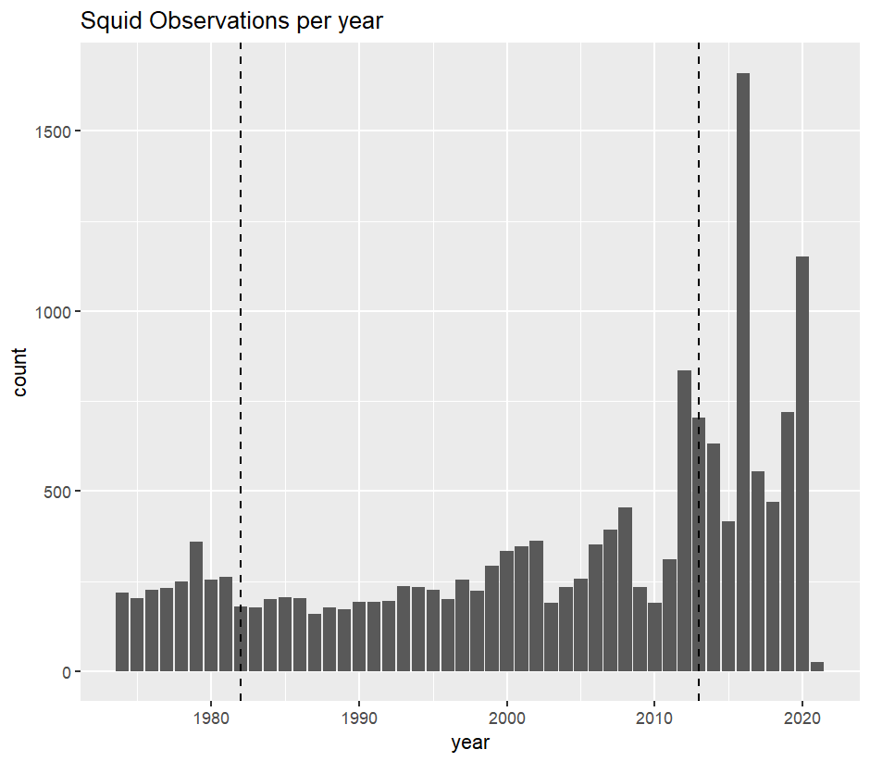

The plot above shows the number of *Doryteuthis pealeii* observations by year. Their observations remained steady from 1974 until around 2010 when they rose sharply. This increase is likely due to a number of new surveys measuring Longfins.

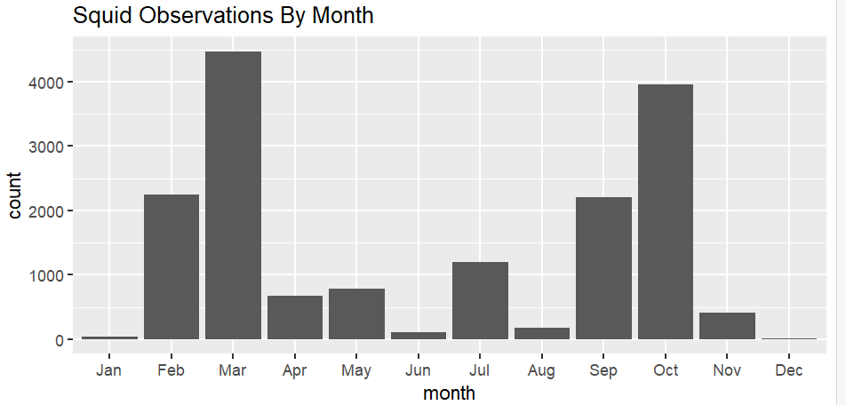

Squid observations are particularly high during the months of February, March, September, and October. During February and March, Longfins are out at sea enjoying warmer waters at the continental shelf. During September and October, they are close to the shore breeding.

## Models

The OBIS data is observation only, and doesn’t include absences. To accurately model habitat suitability, the forecast must also consider the locations with no observations that are still likely to harbor *Doryteuthis pealeii*. A greedy approach was used to find background points, or locations with environments similar to those preferred by Longfins.

Additionally, the covariates used to construct habitat suitability models needed to be considered. A random forest model was made for each month to forecast habitat suitability, and for each month, there were different covariates used. The Brickman data contains measurements for mixed layer depth, sea bottom salinity, sea surface temperature, sea bottom temperature, U, V, Xbtm, depth, and sea surface salinity. To make accurate predictions, covariates with high collinearity were removed from each model. The covariates utilized are as follows:

| Covariate/  Month | MLD | SBTM | SST | TBTM | U | V | Xbtm | depth | SSS |
| --- | --- | --- | --- | --- | --- | --- | --- | --- | --- |
| Jan | x | x | x | x | x | x | x | x |  |
| Feb | x | x | x | x | x | x | x | x |  |
| Mar | x | x | x | x | x | x | x | x | x |
| Apr | x | x | x | x | x | x | x | x | x |
| May | x | x | x | x | x | x |  | x | x |
| Jun | x | x | x | x | x | x |  | x | x |
| Jul | x | x | x | x | x | x | x | x | x |
| Aug | x | x | x | x | x | x |  | x | x |
| Sep | x | x | x | x | x | x |  | x |  |
| Oct | x | x | x | x | x | x |  | x |  |
| Nov | x | x |  | x | x | x | x | x | x |
| Dec | x | x | x | x | x | x | x | x |  |

Xs indicate the covariate was used in that month’s model

20% of the data for each month was split into a testing group, and the rest was used to train that month's model. After the model was created, predicted habitats were compared to actual habitats from the testing group, and the accuracy was measured. (This process was also done using background points generated from a conservative approach, however, for each month, the accuracy was better using the greedy approach). The accuracy for each month’s model is as follows.

January accuracy: 0.611111111111111

February accuracy: 0.723342939481268

March accuracy: 0.832420591456736

April accuracy: 0.721789883268482

May accuracy: 0.802325581395349

June accuracy: 0.855555555555556

July accuracy: 0.897342995169082

August accuracy: 0.688405797101449

September accuracy: 0.637465051258155

October accuracy: 0.648033126293996

November accuracy: 0.798107255520505

December accuracy: 0.545454545454545

With the model trained, it simply had to be given covariates from the region of study, and it could make predictions. Nowcasts were created for each month, by inputting current measurements. Forecasts were made for the years 2055 and 2075 using the predicted covariate measurements under RCP45 and RCP85.

### RCP85 Forecasts

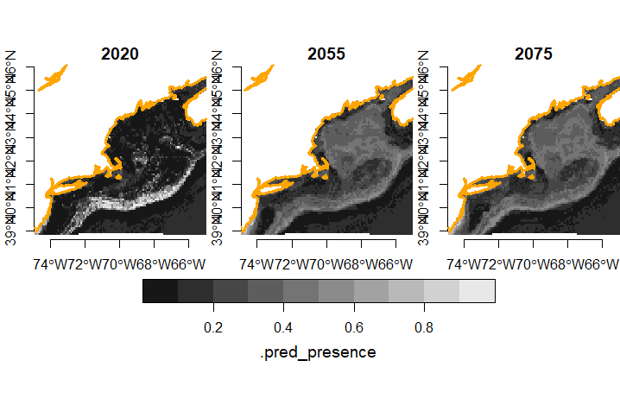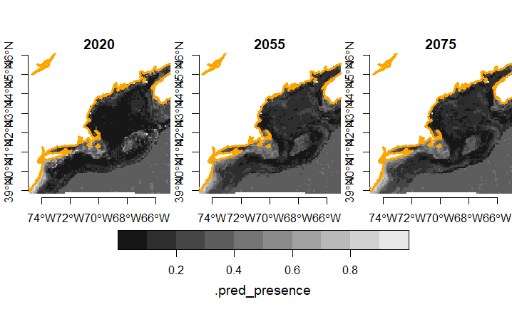

January February

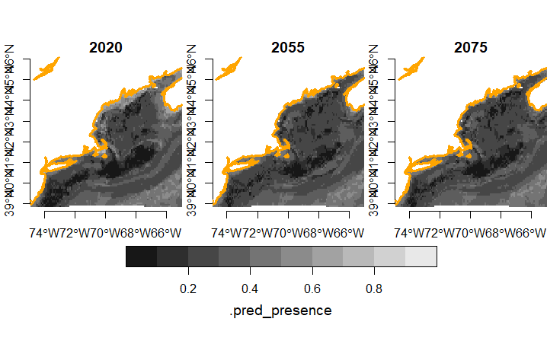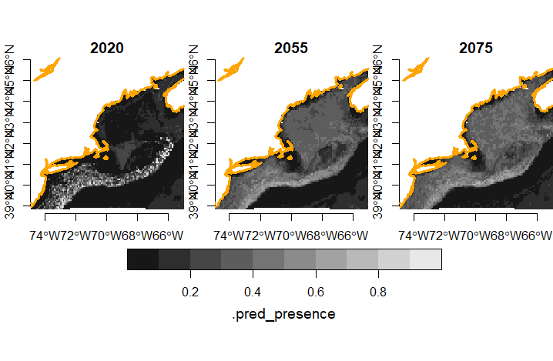

March April

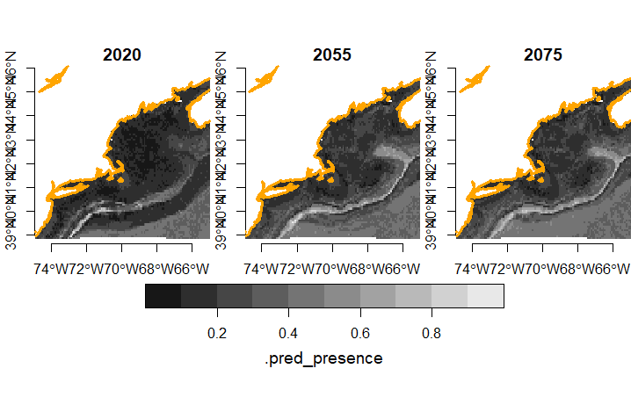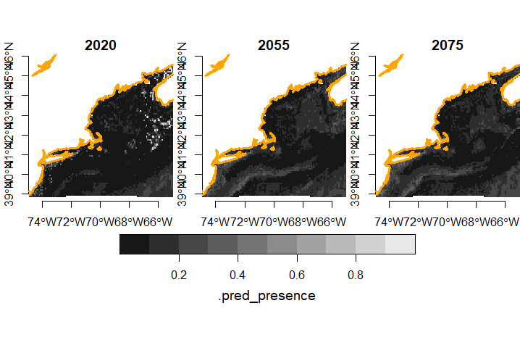

May June

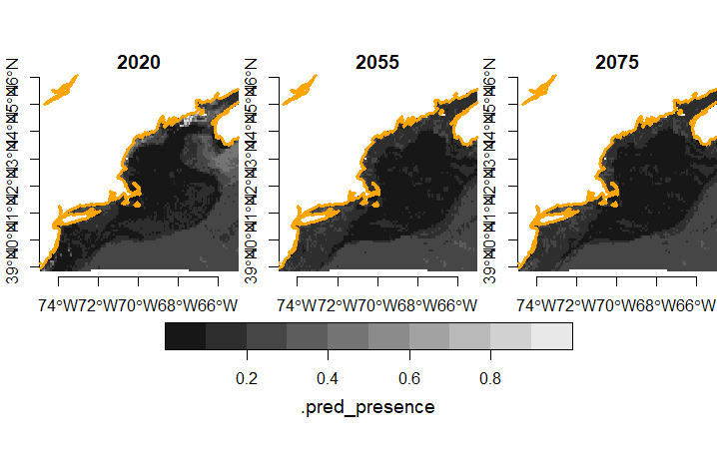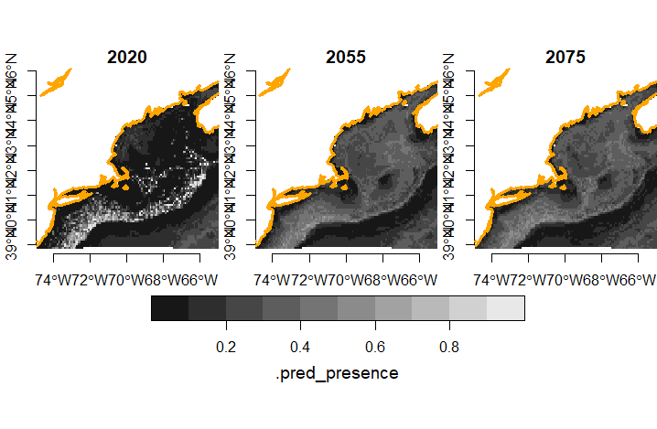

July August

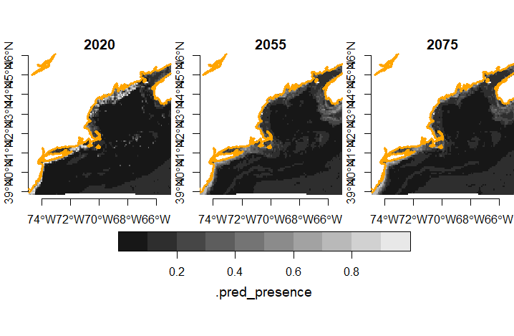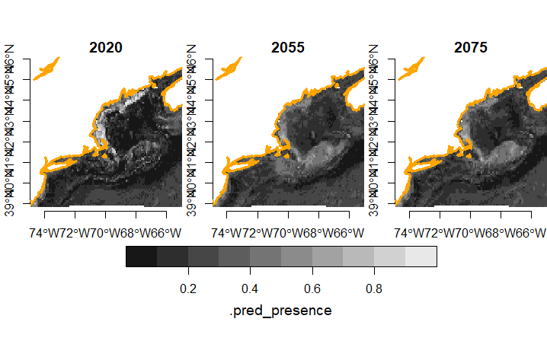

September October

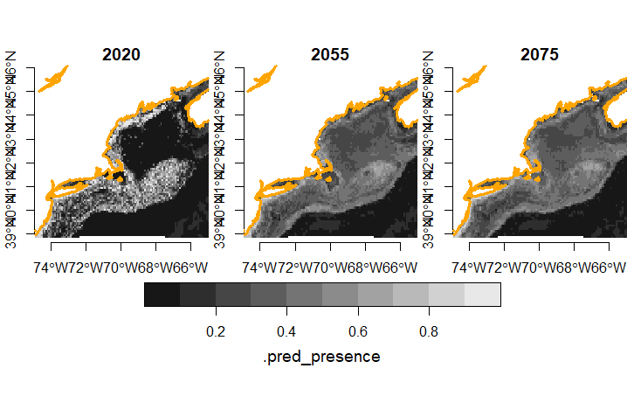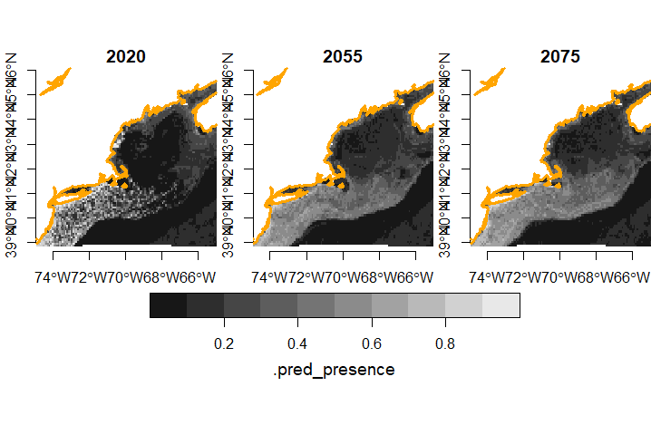

November December

Today, during the winter months, Longfin live at the edge of the Gulf of Maine where the water is warmer. Forecasts predict that in 2055 and 2075, Longfin will move towards the center of the Gulf, where the water will be warm enough for them to survive. Although less definitive, the forecasts predict that habitats across the gulf will become more suitable for the Longfin during their breeding season in the late summer and autumn. Normally only common along the coast, Longfin will spread more into the open water.

### RCP45 Forecasts

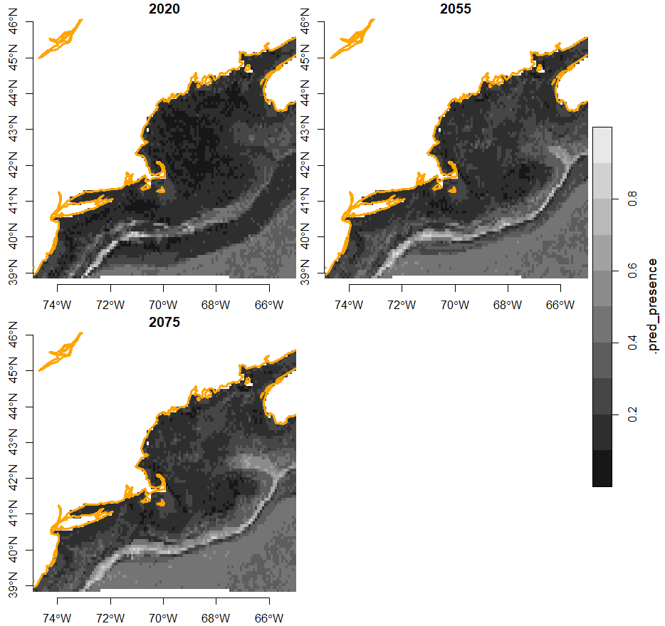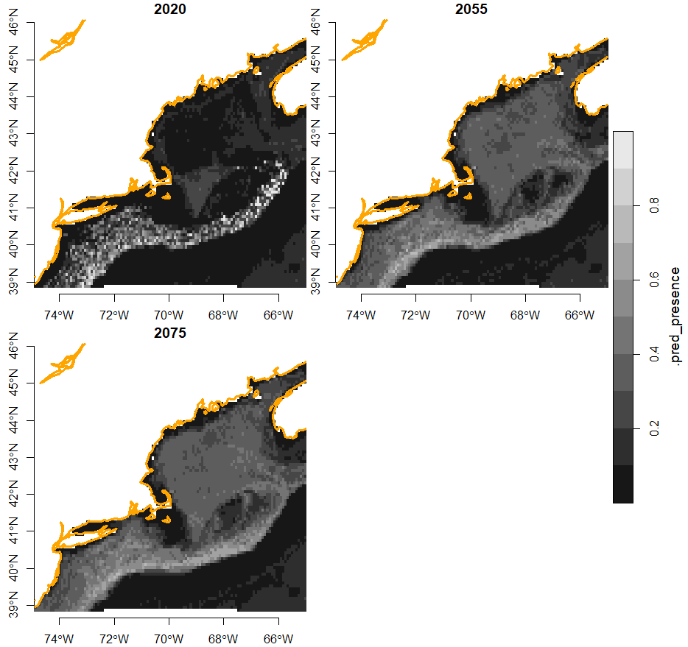

January February

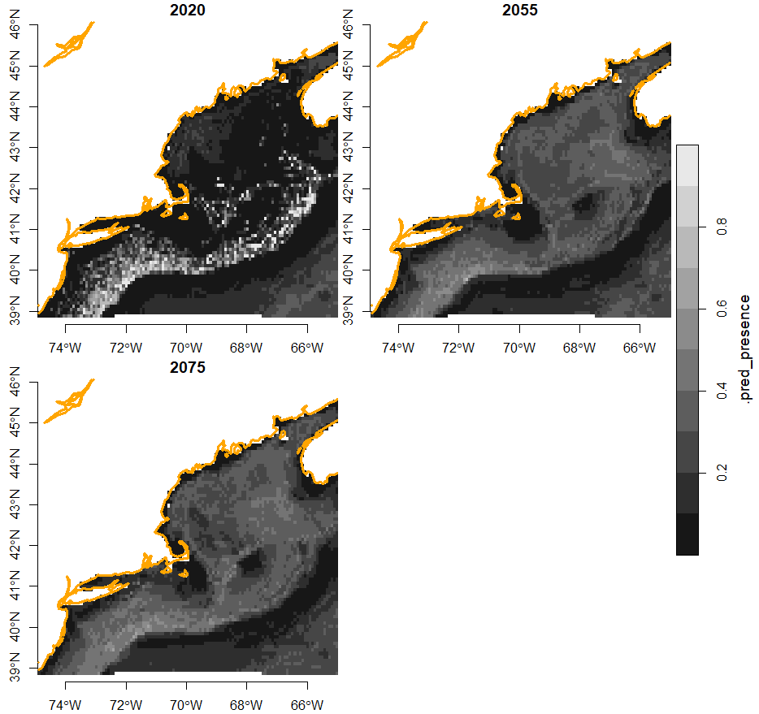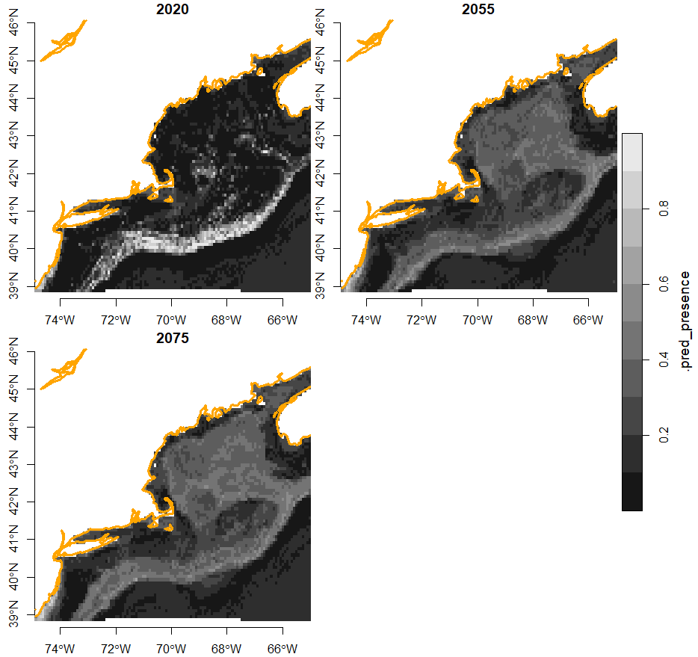

March April

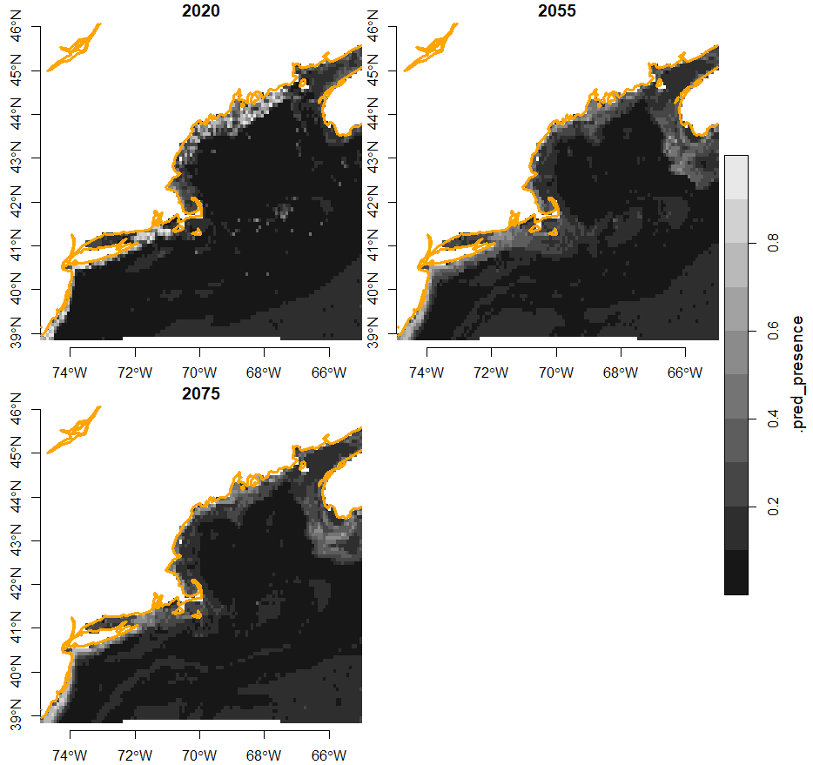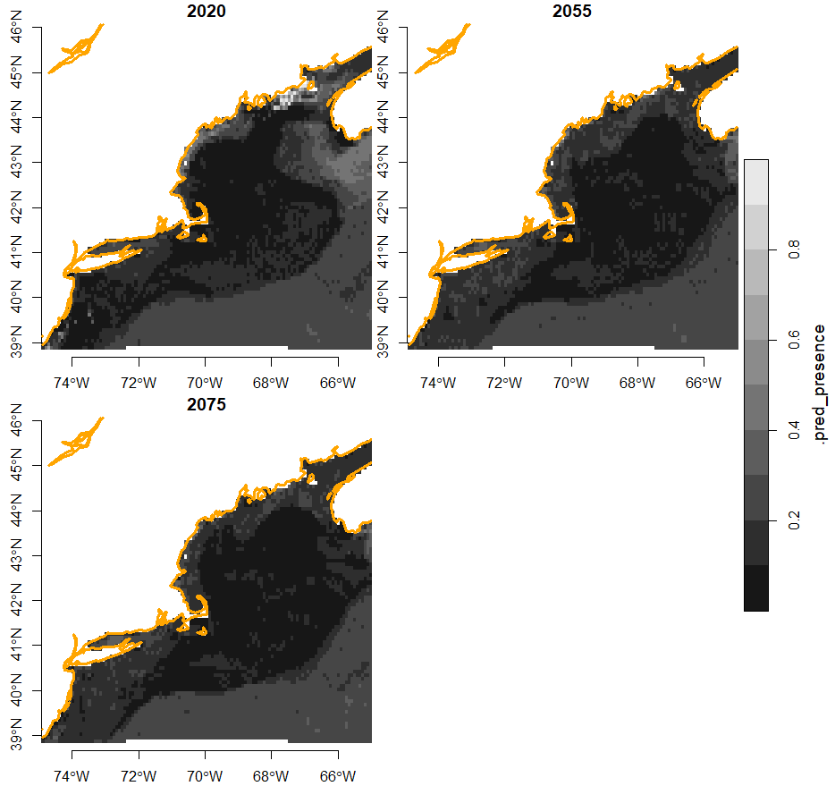

May June

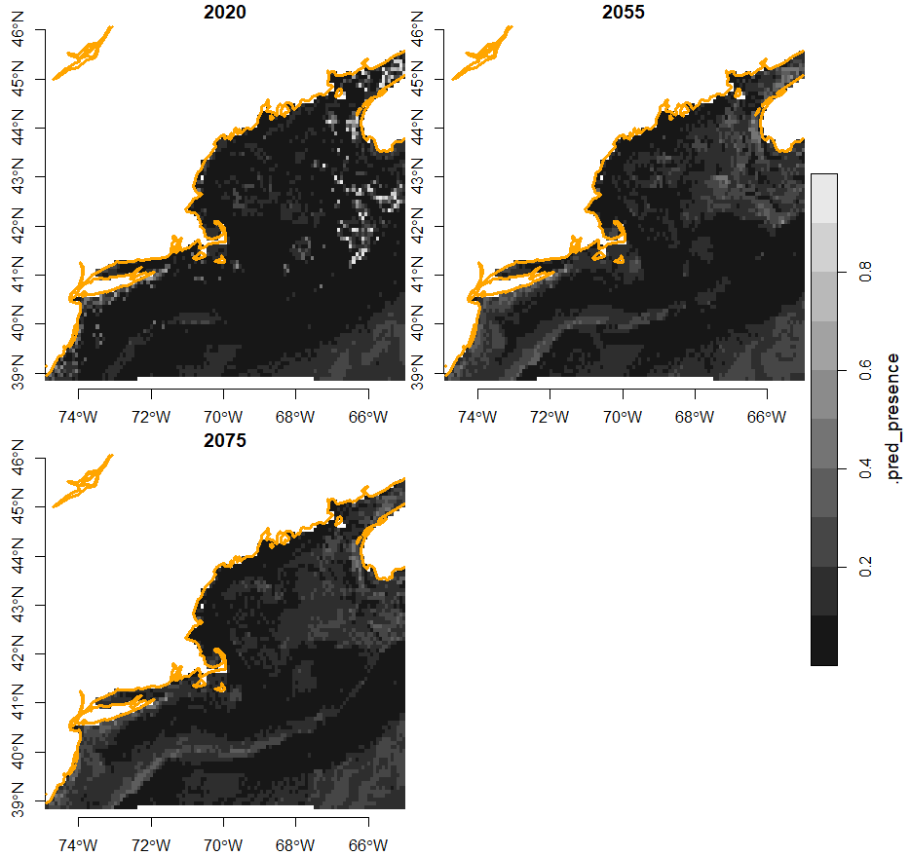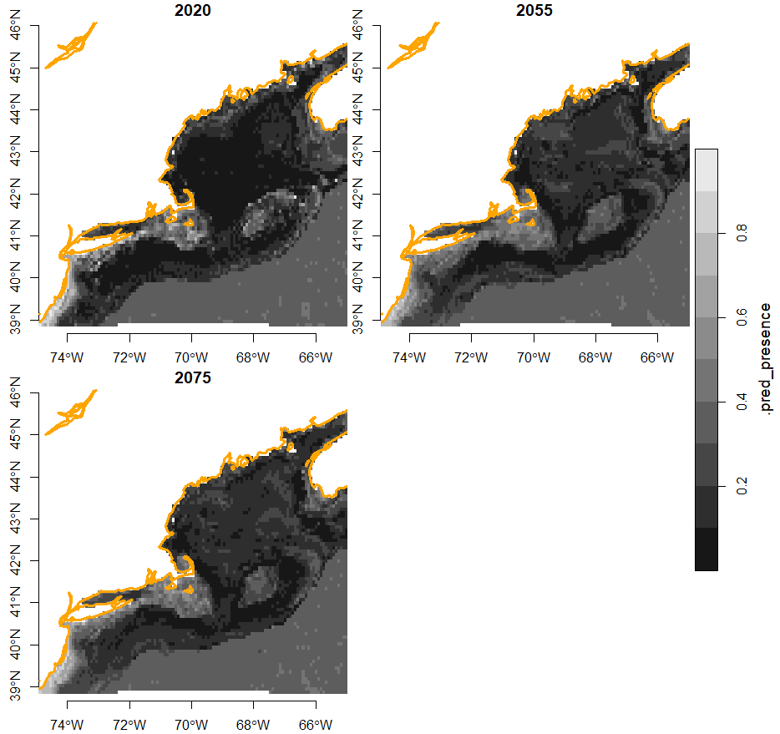

July August

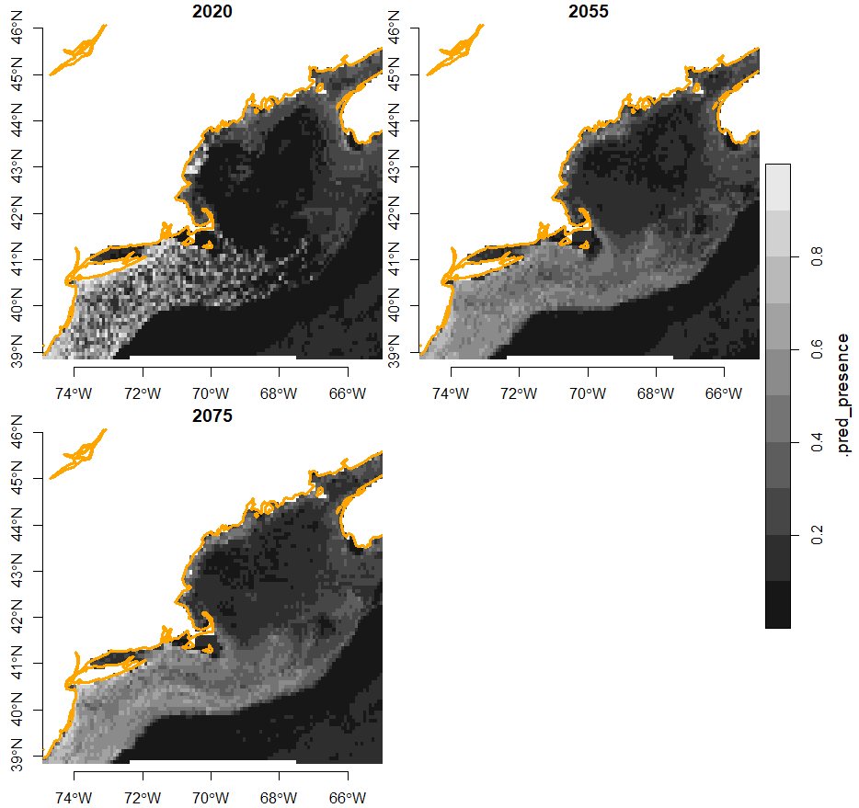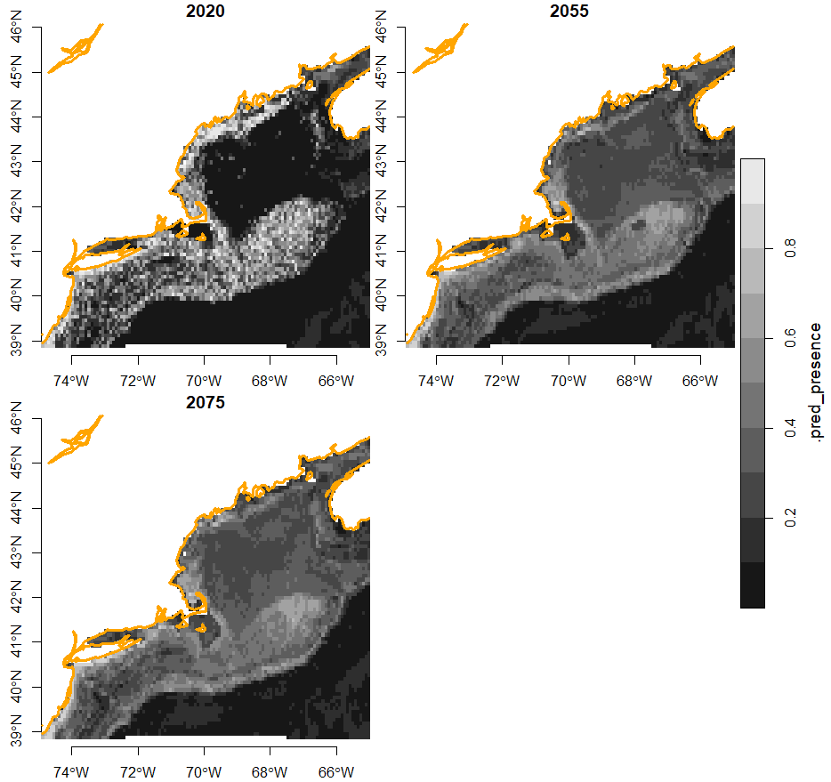

September October

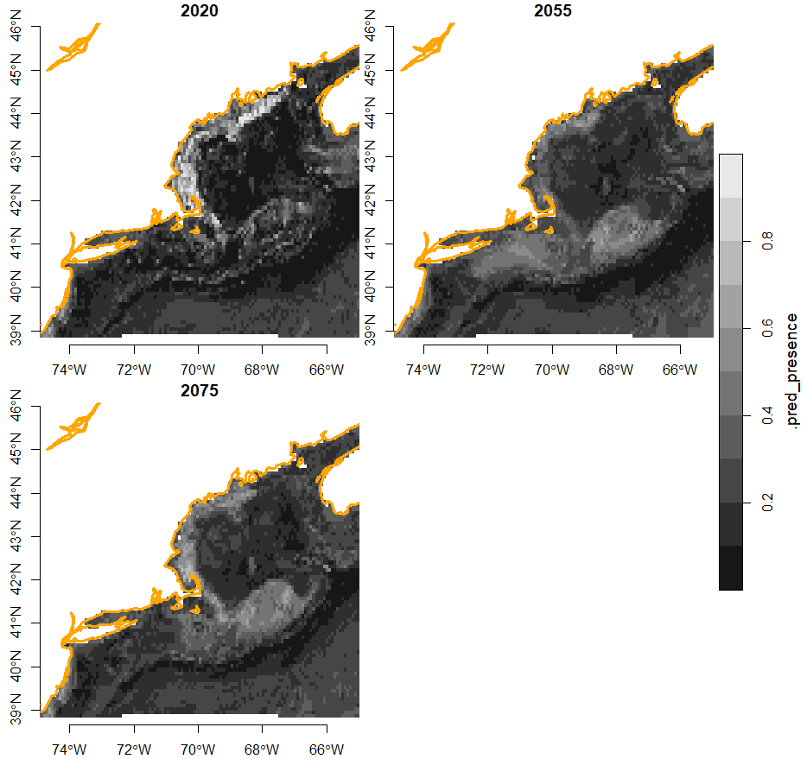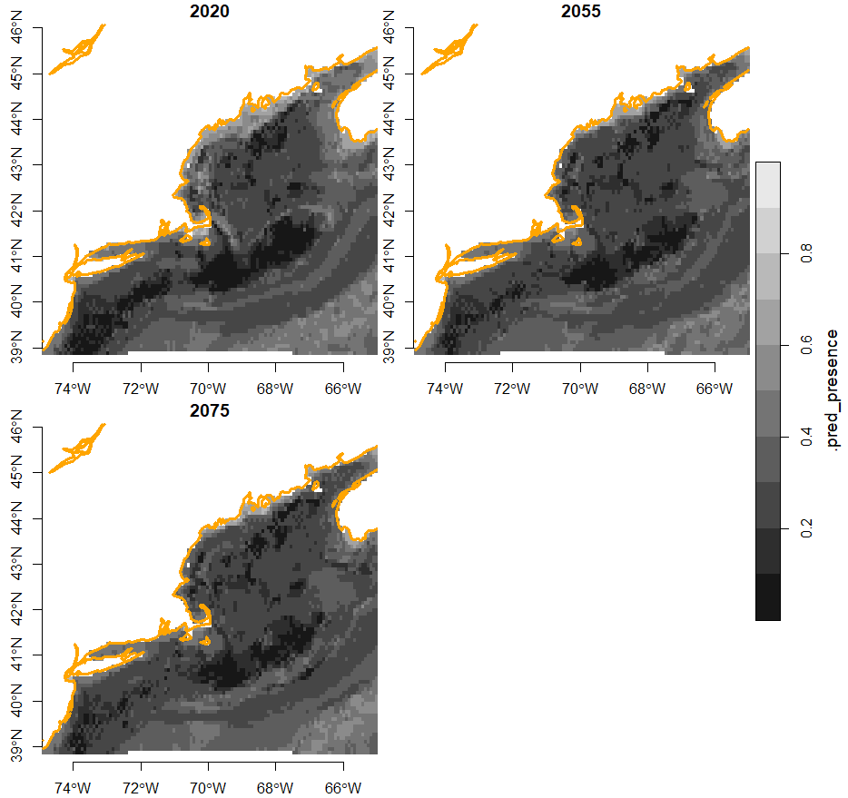

November December

RCP45 predictions show the same trend, but to a lesser degree. During the warmer months, Longfins which previously only lived along the coast will be able to live in the open water in the center of the Gulf. During the winter, they will be able to move inward from the continental slope to the center of the Gulf.

## Implications

My forecasts indicate that Longfin squids will remain in the Gulf of Maine, with more habitats becoming suitable. While the Longfin previously only existed along Maine’s coast and at the edge of the Gulf outside Georges Bank, the center of the Gulf will become suitable for the squids. These findings could be used to help scientists better understand the ecological impacts of global warming. If Longfin are here to stay, it indicates that the Gulf’s population of North Atlantic shrimp, which was wiped out in part due to Longfins, will have a difficult time rebounding. This fact could be utilized by fishermen who previously sought shrimp. If Longfin are in, and shrimp are out, they might switch the focus of their fishing to the squid. This event could pose a risk to other marine life in the Gulf of Maine. Longfins are caught using small-mesh bottom trawls, which can inadvertently catch whales, dolphins, sharks and other larger organisms.

The results of this study could also be used to justify limited carbon emission reductions from an economic standpoint. If forecasts indicate that global warming will result in more Longfin squid, policymakers and lobbyists could seize upon the fact that this brings economic opportunity to fishermen. Rising temperatures have already wiped out one fishery in the Gulf of Maine, but it appears that they could bring another to replace it. If the negative economic effects of global warming are offset by positives, policymakers might be less inclined to take action to halt it.

The intended effect of this study is to explore the impact global warming will have on the range of *Doryteuthis pealeii*, and how policy decisions can affect this change. Forecasts predict that Longfin squids will remain in the Gulf of Maine, and their potential habitats will only expand over time. Hopefully this study provides evidence that global warming will affect the humans and organisms throughout the Gulf region, and that through intervention, its effects can be eased.

1. Woodard, Colin. *Big Changes Are Occurring in One of the Fastest-Warming Spots on Earth*, 25 Oct. 2015, https://www.pressherald.com/2015/10/25/climate-change-imperils-gulf-maine-people-plants-species-rely/.
2. Marine Heatwave.” *Gulf Of Maine Research Institute*, 22 Aug. 2019, gmri.org/stories/marine-heatwave/.
3. Bever, Fred. “Scientists Think Longfin Squid Are Reason for Maine’s Prized Shrimp Fishery Collapse.” *WBUR News*, 4 Oct. 2021, www.wbur.org/news/2021/10/04/maine-shrimp-longfin-squid-warming-waters.
4. Fisheries, NOAA. “Longfin Squid.” *NOAA*, 27 Nov. 2024, www.fisheries.noaa.gov/species/longfin-squid.
5. “Doryteuthis Pealeii, Longfin Inshore Squid.” *Doryteuthis Pealeii, Longfin Inshore Squid. : NE CASC*, necasc.umass.edu/biblio/doryteuthis-pealeii-longfin-inshore-squid. Accessed 30 Jan. 2025.
6. Brickman, David. *Projections of Physical Conditions in the Gulf of Maine in 2050 | Elementa: Science of the Anthropocene | University of California Press*, online.ucpress.edu/elementa/article/9/1/00055/116900/Projections-of-physical-conditions-in-the-Gulf-of. Accessed 31 Jan. 2025.